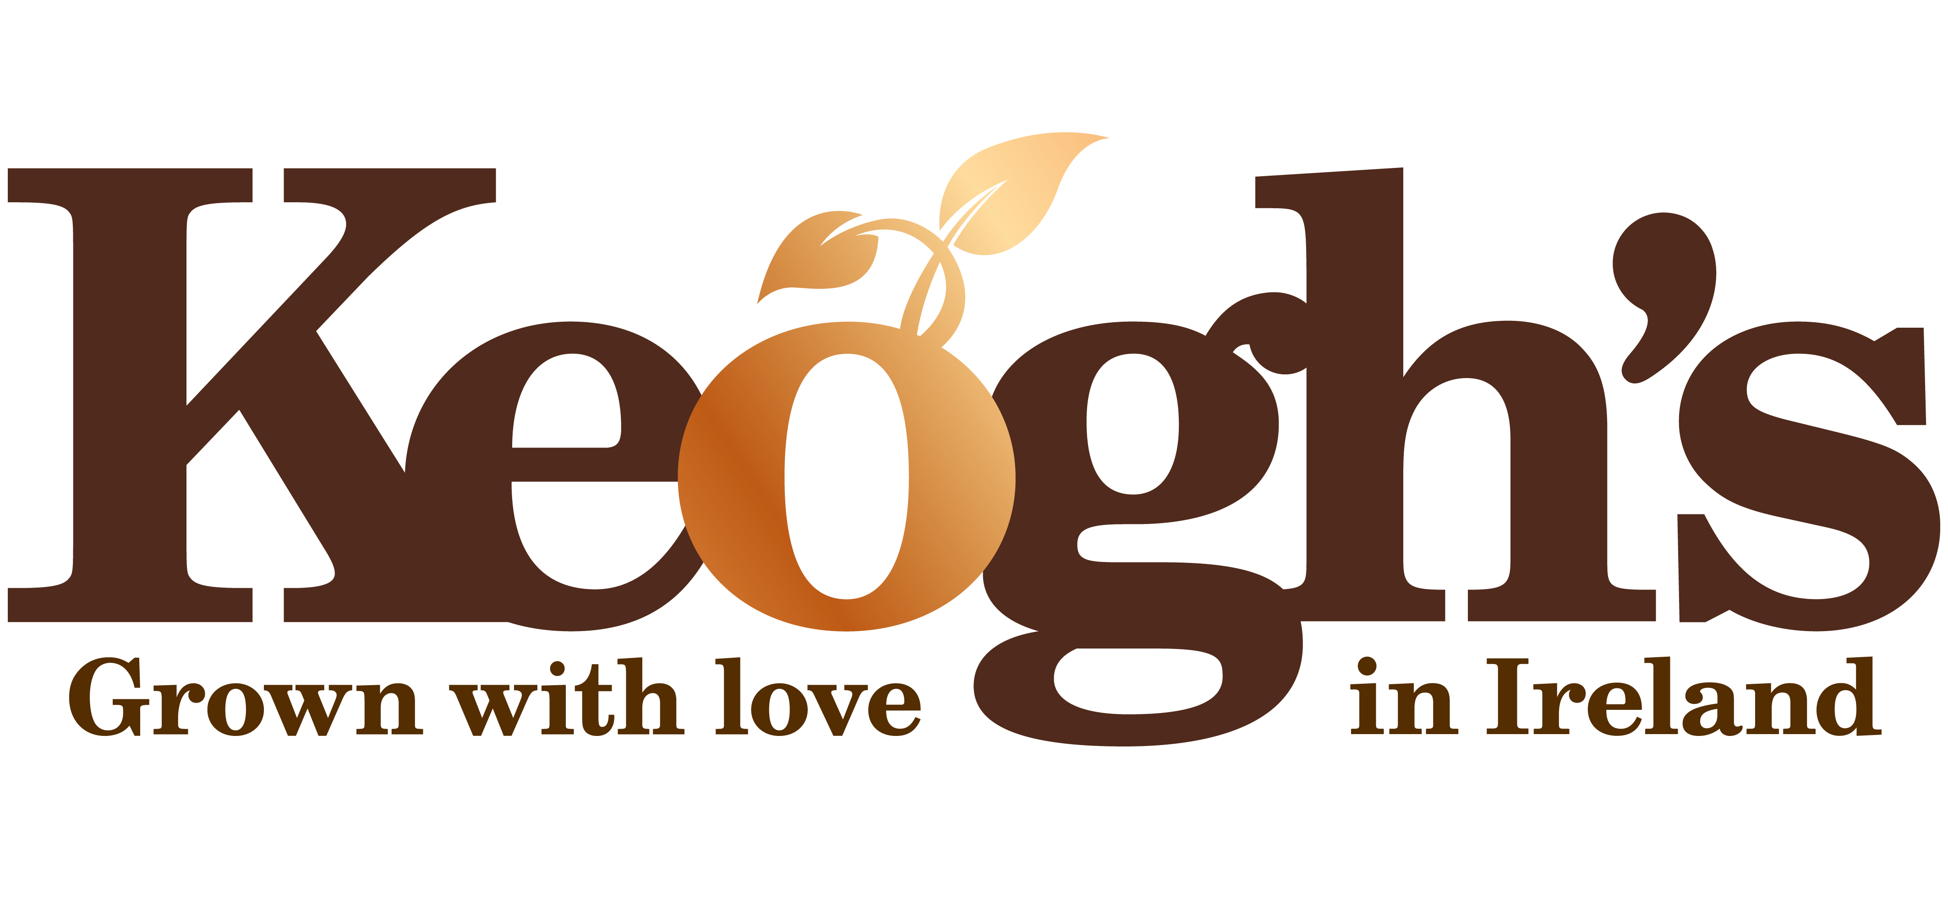

**Media Release**

**Irish Chorizo and Cherry Tomato is a Winning Combo for Keogh’s**

***Irish Potato Producers Launch NEW Limited Edition Flavour Crisps***

Fans of unique Irish flavours will love **Irish Chorizo and Cherry Tomato,** the brand new flavour from Keogh’s Crisps. The **limited edition** flavour is the result of a carefully crafted collaboration between the **Gubbeen Smokehouse** in Co. Cork and **Keogh’s Farm**, producers of the highest quality Irish potatoes and crisps.

Available later this month in selected stores, for a limited period, Irish Chorizo and Cherry Tomato is the first new crisp flavour to be brought to market by Keogh’s Farm in 2 years. Tom Keogh, Managing Director at Keogh’s Farm, explains:

*“Creating a new flavour is a hard thing to do, especially when you’re as careful and considered as we are with our crisps! That said, once we had decided upon the flavour direction that we wanted to try, we knew right away that the team in Gubbeen were the perfect partners for us. Fingal’s passion for locally-sourced and home-cooked food fits perfectly with the Keogh’s ethos and we are proud to be championing another superb Irish supplier.”*

*“From listening to our customers, we knew that they were ready for us to bring out a new, sophisticated flavour and we believe that Irish Chorizo and Cherry Tomato meets the criteria. We’ve done lots of taste tests and the flavour is a massive hit with all of our family so we hope the Irish public love it as much as we do!”*

Gubbeen’s Fingal Ferguson added: *“We are really excited to have been asked by Keogh’s to collaborate on their new crisp flavour. Tom Keogh and the team came to visit our smokehouse in West Cork to see how we make our products. This was an important part of the process which helped us to create the perfect crisp. The sweet cherry tomato is an ideal companion to the smoky spicy chorizo!”*

*“It has been a pleasure to work with fellow Irish farmers and seeing the passion that the Keogh family have for what they do has been wonderful. I feel that this is an important collaboration and the end product more than lives up to the high standard that consumers have rightly come to expect from Irish food producers!”*

Keogh’s Irish Chorizo and Cherry Tomato crisps are hand-cooked on the family farm in North County Dublin and, as with all Keogh’s products, are certified gluten-free. Existing flavours in the crisp range include Sea Salt & Irish Cider Vinegar, Shamrock & Sour Cream, Roast Beef & Irish Stout, Dubliner Irish Cheese & Onion, Irish Atlantic Sea Salt, Sweet Chilli & Irish Red Pepper and the seasonal Roast Turkey and Secret Stuffing.

Keogh’s Farm are welcoming customers to give their feedback on the new flavour, and limited edition packaging, on their social media channels. Search **@KeoghsFarm** on Facebook, Twitter and Instagram.

Keogh’s Irish Chorizo and Cherry Tomato crisps are available in 50g or 125g in participating stores nationwide later this month. RRP €1.20-€2.89

For further information on Keogh’s Farm, visit [**www.keoghs.ie**](http://www.keoghs.ie)**.**

**-ENDS-**

**For further information please contact:**

Sarah Lacey / Tabitha Bourke-Cooney

[keoghs@psgcomms.ie](mailto:keoghs@psgcomms.ie)

+353 1 661 4055

**Notes to Editor**

**About Keogh’s Farm**

Keogh's Farm is a family owned and run potato growing and crisping business based in North County Dublin, an area famous for producing Ireland’s finest potatoes.

The Keogh Family has been farming the rich fertile lands in this area for over 200 years and now produce Ireland’s only “hand cooked on the farm” artisan potato crisps since 2011. Special crisping potato varieties are chosen, grown in fertile soils and harvested with extra care and a lot of love - from crop to crisp!

Keogh’s use only the finest, carefully selected authentic Irish food ingredients to create their delicious flavours: Atlantic Sea Salt & Irish Cider Vinegar, Shamrock & Sour Cream, Roast Beef & Irish Stout, Dubliner Irish Cheese & Onion, Irish Atlantic Sea Salt, Sweet Chilli & Irish Red Pepper and the seasonal Roast Turkey and Secret Stuffing. All varieties are gluten free.